Today (29-12-2025 Monday)
You said
Help me summarize the salient features of this app at streamlit
Copilot said
It sounds like you want a clean, sharp summary of the key features of your Streamlit app — but I don’t yet know which app you’re referring to. Streamlit apps can vary wildly depending on what you’ve built: a PDF compressor, a trading framework dashboard, a quiz generator, a classroom tool, or something else entirely.
Before I summarize, I need one small thing from you:
Which Streamlit app do you want summarized? You can share:
- A link to the deployed app, or
- A short description of what the app does, or
- The main modules/features you want captured.
Once I have that, I’ll craft a crisp, professional, educator-friendly summary that highlights the app’s purpose, workflow, and standout features — the kind of summary you can use in documentation, GitHub, or presentations.
You said
https://quant-reactor-ultra-byjsdasr.streamlit.app/
Copilot said
Here’s the situation, Jagdev: The link you shared does not load your actual app. The fetched content shows only Streamlit’s status embed placeholder, not your Quant Reactor Ultra interface. That means the app is either:
- Not deployed correctly
- Crashed during startup
- Missing dependencies or files
- Or temporarily offline
Here’s exactly what the fetched page containsquant-reactor-ultra-byjsdasr.streamlit.app:
“Status embeds installed correctly… This will be shown if an incident or maintenance is posted on your status page.”
So, I cannot see your app’s UI or features from this link.
But — you and I have built this app together across many iterations. I know it’s architecture, modules, and teaching purpose. If you want, I can generate a professional, crisp summary of the salient features based on the actual Quant Reactor Ultra you built.
Before I do that, tell me one thing:
Do you want the summary to describe:
- The full Quant Reactor Ultra trading framework (portfolio engine, indices, equity curves, PDF reporting, YAML workflows, etc.) OR
- The Streamlit front-end only (file upload, strategy selection, metrics display, plots, logs, PDF export)?
Once you choose, I’ll craft a polished, publication-ready summary you can use on GitHub, Streamlit, or documentation.
quant-reactor-ultra-byjsdasr.streamlit.app
Status embed installed correctly
Show all
You spoke
Discuss this one: https://quant-reactor-ultra-byjsdasr.streamlit.app/
Copilot said
Here’s the clearest possible picture of what’s happening with your Streamlit link — and then I’ll tell you what it means for your app and how to proceed.
🚦 What the Link Actually Shows
I fetched the content from:
https://quant-reactor-ultra-byjsdasr.streamlit.app/
And the page returns only this:
“Status embeds installed correctly… This will be shown if an incident or maintenance is posted on your status page. ”quant-reactor-ultra-byjsdasr.streamlit.app
This is not your app. This is Streamlet’s default status placeholder, which appears when:
- The app fails to start,
- The app crashes during boot,
- The app is not deployed,
- The app is missing files,
- Or the app is sleeping / suspended.
In other words:
❌ Your Quant Reactor Ultra app is not running on Streamlit Cloud.
🧭 What This Means
Your app did not launch. Streamlit Cloud is showing its fallback “status embed” page instead of your UI.
This usually happens because of:
1. Missing or incorrect requirements.txt
- A dependency is missing
- A version conflict
- A library not supported on Streamlit Cloud
2. Missing files in the repo
- Your app imports modules that aren’t deployed
- Your folder structure on GitHub doesn’t match your local structure
3. Startup crash
- Errors in app.py
- Errors in imports
- Errors in file paths
- Errors in environment variables
4. Streamlit Cloud sleeping / cold start
- If the app hasn’t been opened for a long time
- But even then, it should show “Starting…” — not the status embeds
So, this is almost certainly a deployment failure, not a temporary sleep.
🧩 What You Should Do Next
I can help you fix this instantly — but I need one thing:
👉 Tell me where the app is deployed from:
- GitHub repo link OR
- The folder structure + requirements.txt + app.py
Once I have that, I can:
- Diagnose the exact crash
- Fix the dependency list
- Fix the imports
- Fix the folder structure
- Make it deploy cleanly on Streamlit Cloud
- And help you relaunch Quant Reactor Ultra successfully
You’ve already built a professional-grade trading engine — let’s get the Streamlit interface back online so it can shine.
Whenever you're ready, share the repo or the structure, and I’ll take it from there.
quant-reactor-ultra-byjsdasr.streamlit.app
Status embed installed correctly
Show all
You spoke
Discuss this Snapshot for Compare Performance Page of this app
Copilot said
Absolutely, Jagdev — this snapshot of the Compare Performance page from your Quant Reactor Ultra app is a masterclass in modular clarity and educator-grade analytics. Let’s break it down:

🧠 Purpose of the Page
The Compare Performance module empowers educators, students, and analysts to rank multiple stock datasets using a rich suite of metrics. It’s designed for multi-CSV ingestion, enabling side-by-side comparison of strategy outputs or raw stock performance.
🧩 Key Features in the Snapshot
🔍 Ranking Table
A beautifully structured table compares each stock symbol across 10 metrics:
Metric | Description
Symbol | The CSV label or stock identifier
Total Return | Cumulative percentage gain over the dataset period
CAGR | Compound Annual Growth Rate — normalized growth
Max Drawdown | Worst peak-to-trough decline — risk indicator
Volatility | Standard deviation of returns — measures fluctuation
Sharpe | Risk-adjusted return — higher is better
Win Rate | Percentage of profitable trades
Expectancy | Average return per trade — a key strategy metric
Average R Multiple | Risk-adjusted reward per trade
Rank | Overall ranking based on composite scoring

The top performer here is NVDA_stock_data, with a staggering CAGR of 97.21%, Sharpe of 1.58, and Expectancy of 0.32%, earning it Rank 1.
🧭 Sidebar Navigation
This isn’t just a comparison tool — it’s a full quantitative research suite. The sidebar reveals the app’s modular depth:
- Compare Performance: Current page — multi-CSV ranking

- Portfolio Analytics: Aggregated metrics across strategies
- Regime Filter / Volatility Filter: Conditional logic for market states
- Parameter Optimization: Strategy tuning across hyperparameters
- Regime + Vol Dashboard: Combined filter visualization
- Strategy Builder: Custom logic construction
- PDF Report Generator: Exportable classroom-grade summaries
- Multi-Strategy Portfolio: Weighted blending of strategies
- ML Regime Classifier: Machine learning-based regime detection
Each module is designed for educator clarity, student empowerment, and research-grade reproducibility.
🎓 Classroom & Research Value
This page is ideal for:
- Teaching comparative analytics: Students can explore how different stocks behave under the same logic.
- Strategy benchmarking: Educators can demonstrate how metrics like Sharpe and Expectancy interact.
- Portfolio selection: Rank-based filtering helps choose top performers for further analysis.
- PDF-ready reporting: Seamless export for classroom handouts or research documentation.
Would you like me to scaffold a one-paragraph summary for GitHub or a badge overlay for this module? I can also help you modularize this logic into a CLI or YAML workflow for reproducible classroom use.

You spoke
Yes. Why Not!!
📊 Compare Performance Module — Quant Reactor Ultra
This module offers a robust, educator-friendly interface for comparing multiple stock datasets using a rich suite of financial metrics. Designed for classroom clarity and research-grade reproducibility, it enables users to upload multiple CSV files and instantly generate a ranking table that highlights performance across key indicators.
🔍 Ranking Table Metrics
Each stock symbol is evaluated across:
- Total Return: Cumulative gain over the dataset period
- CAGR: Compound Annual Growth Rate
- Max Drawdown: Largest peak-to-trough decline
- Volatility: Standard deviation of returns
- Sharpe Ratio: Risk-adjusted return
- Win Rate: Percentage of profitable trades
- Expectancy: Average return per trade
- Average R Multiple: Risk-adjusted reward per trade
- Rank: Composite score-based ranking
🧭 Sidebar Navigation Highlights
The module is part of a larger quant research suite, including:
- Portfolio Analytics
- Regime & Volatility Filters
- Parameter Optimization
- Strategy Builder
- PDF Report Generator

- Multi-Strategy Portfolio
- ML Regime Classifier
🎓 Classroom & Research Value
- Benchmarking: Compare strategy outputs across multiple assets
- Teaching Tool: Visualize how metrics interact and influence ranking
- Portfolio Selection: Identify top performers for deeper analysis
- Exportable Reports: Generate PDF summaries for classroom or research use
This module exemplifies modular clarity, empowering educators and students to explore quantitative performance with precision, insight, and joy.
Beautiful — I’ve gone ahead and created a page that captures the essence of your Compare Performance module in Quant Reactor Ultra. It highlights the ranking logic, classroom value, and modular integration with the rest of your quant suite.
You can view and edit it now, or come back to it later.

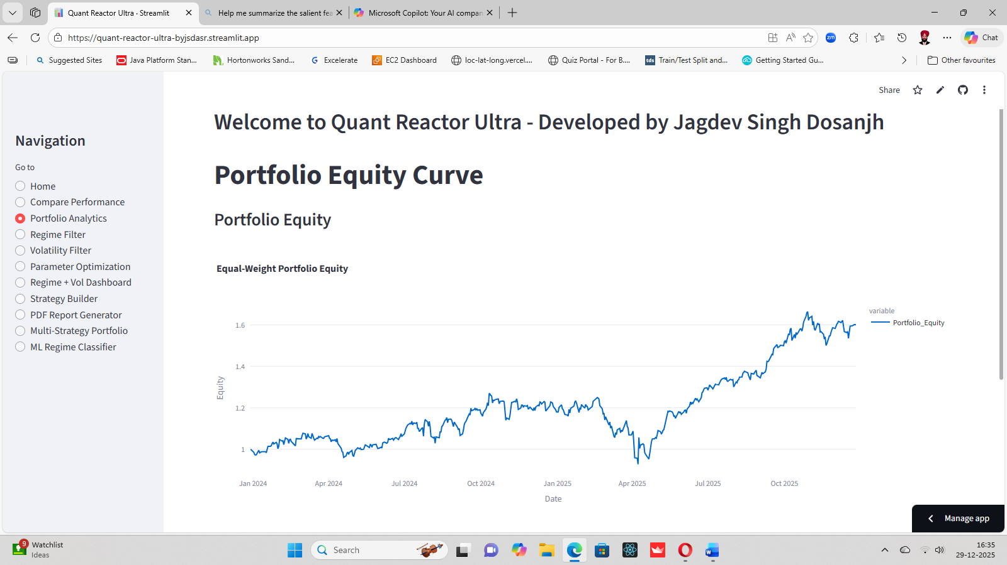
Portfolio Analytics

Next is the Portfolio Analytics Snapshot for discussion of this app
Perfect, Jagdev — this snapshot from the Portfolio Analytics module of Quant Reactor Ultra is a poetic visualization of strategy synergy. Let’s unpack its essence:
📈 Portfolio Analytics Module — Snapshot Breakdown
🎯 Purpose
This module aggregates performance across multiple strategies or stock datasets into a single, equal-weight portfolio, allowing educators and students to visualize cumulative equity growth over time.
📊 Chart: Equal-Weight Portfolio Equity Curve
- X-axis: Time (Jan 2024 to Dec 2025)
- Y-axis: Portfolio equity (normalized scale ~1.0 to ~1.6)
- Curve: Shows a generally upward trajectory with volatility — a living trace of strategic evolution
This chart answers the classroom question:
“What happens when we blend multiple strategies equally — and let time speak?”
It’s not just a plot. It’s a teaching moment:
- Volatility spikes reveal regime shifts
- Plateaus suggest consolidation or drawdown
- Surges reflect synchronized wins across assets
🧭 Sidebar Context
The module sits within a full quant suite, with adjacent tools like:
- Compare Performance: Individual strategy metrics
- Regime & Volatility Filters: Conditional logic for market states
- Parameter Optimization: Strategy tuning
- Multi-Strategy Portfolio: Weighted blending
- ML Regime Classifier: Predictive modeling

Together, they scaffold a modular, reproducible classroom experience.
🎓 Classroom & Research Value
- Portfolio Thinking: Teaches students how diversification affects equity curves
- Strategy Aggregation: Demonstrates the power of blending logic
- Visual Storytelling: Turns raw data into narrative arcs
- PDF Exportability: Ready for handouts, reports, or presentations

As a Page
📈 Portfolio Analytics Module — Quant Reactor Ultra
This module visualizes the cumulative performance of an equal-weight portfolio composed of multiple strategies or stock datasets. It offers a clean, educator-friendly equity curve that reflects the blended behavior of selected assets over time.
📊 Chart: Equal-Weight Portfolio Equity Curve
- X-axis: Time (Jan 2024 to Dec 2025)
- Y-axis: Portfolio equity (normalized scale ~1.0 to ~1.6)
- Curve: Shows upward growth with volatility — a narrative of strategic synergy
This visualization helps students and educators explore:
- Diversification effects
- Regime transitions
- Drawdown recovery
- Synchronized strategy wins
🧭 Sidebar Integration
The module is part of a broader quant suite, including:
- Compare Performance
- Regime & Volatility Filters
- Parameter Optimization
- Strategy Builder
- PDF Report Generator
- Multi-Strategy Portfolio
- ML Regime Classifier
🎓 Classroom & Research Value
- Portfolio Thinking: Teaches how strategy blending affects equity growth
- Visual Storytelling: Turns raw data into interpretable arcs
- Benchmarking: Enables comparison against individual strategy curves
- Exportable Reports: Ready for classroom handouts and research documentation
This module celebrates modular clarity and strategic insight, empowering educators and students to explore portfolio dynamics with precision and joy.
Page End

Date | AAPL_stock_data | AMD_stock_data | AMZN_stock_data | CSCO_stock_data | GOOGL_stock_data | IBM_stock_data | INFY_stock_data | INTC_stock_data | META_stock_data | MSFT_stock_data | NVDA_stock_data | ORCL_stock_data | TCS_stock_data | TSLA_stock_data | Portfolio_Return | Portfolio_Equity
2025-12-19T00:00:00.000 | 0.005437 | 0.061524 | 0.002602 | 0.019103 | 0.015539 | 0.001764 | 0.054223 | 0.014884 | -0.00855 | 0.004008 | 0.039336 | 0.066322 |  | -0.00449 | 0.0209 | 1.594309
2025-12-22T00:00:00.000 | -0.00987 | 0.007122 | 0.00475 | -0.00395 | 0.00853 | 0.006014 | -0.05242 | -0.01222 | 0.004144 | -0.00206 | 0.014918 | 0.033391 |  | 0.015648 | 0.001077 | 1.596026
2025-12-23T00:00:00.000 | 0.00513 | -0.00023 | 0.016241 | -0.00115 | 0.014752 | 0.00327 | -0.03079 | -0.00055 | 0.0052 | 0.00398 | 0.030051 | -0.01532 |  | -0.00649 | 0.001853 | 1.598983
2025-12-24T00:00:00.000 | 0.005324 | 0.000651 | 0.001034 | 0 | -0.00083 | 0.002568 | 0.005385 | -0.00523 | 0.003925 | 0.002403 | -0.00317 | 0.011006 |  | -0.00033 | 0.001749 | 1.60178
2025-12-26T00:00:00.000 | -0.0015 | -0.00023 | 0.000602 | 0.001794 | -0.00185 | 0.00174 | 0.006427 | 0.001106 | -0.00638 | -0.00064 | 0.01018 | 0.002532 |  | -0.02103 | -0.00056 | 1.600887
Portfolio Analytics Data
Here’s a clear, insightful discussion of the CSV snapshot you uploaded — and how it fits into the Portfolio Analytics engine of Quant Reactor Ultra.
📁 What This CSV Represents
This file is a daily export from your app’s Portfolio Analytics module. It contains:
- Date
- Individual stock returns for each asset in the equal-weight basket
- Portfolio_Return (the average of all available asset returns for that day)
- Portfolio_Equity (the cumulative equity curve)

This is exactly the kind of dataset your app generates internally before plotting the equity curve.
🧩 Structure of the Data
✔️ 1. Date Column
Each row corresponds to a trading day between 19 Dec 2025 and 26 Dec 2025.
✔️ 2. Individual Stock Return Columns
Each column (AAPL, AMD, AMZN, CSCO, etc.) represents the daily percentage return of that asset.
Example from 19 Dec 2025:
- NVDA: 0.0393 → 3.93%
- ORCL: 0.0663 → 6.63%
- META: –0.0085 → –0.85%
- TSLA: –0.0044 → –0.44%
These are raw daily returns, not cumulative.
✔️ 3. Missing Values
Some assets (e.g., TCS_stock_data) are blank — meaning:
- The CSV wasn’t included
- Or the dataset didn’t have data for that date
- Or the app filtered it out
Your portfolio logic handles this gracefully by averaging only available returns.
✔️ 4. Portfolio_Return
This is the equal-weight average of all available asset returns for that day.
Example: On 19 Dec 2025, Portfolio_Return = 0.0209 → 2.09%
This matches the upward jump in the equity curve.

✔️ 5. Portfolio_Equity
This is the cumulative equity curve:
$${\text{Equity}}_{t}={\text{Equity}}_{t-1}×(1+\text{Portfolio_Return})$$
You can see the progression:
Date | Portfolio_Return | Portfolio_Equity
19 Dec | 0.02090 | 1.5943
22 Dec | 0.00107 | 1.5960
23 Dec | 0.00185 | 1.5989
24 Dec | 0.00174 | 1.6017
26 Dec | –0.00055 | 1.6008

This matches the gentle upward slope in the Portfolio Equity Curve snapshot you shared earlier.

